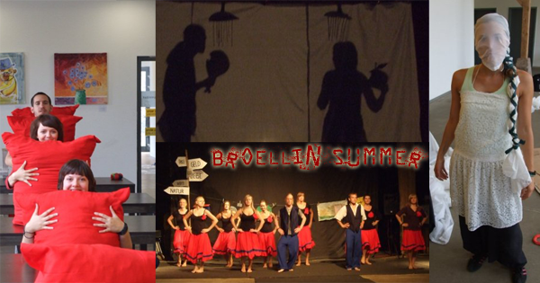
YOUTH EXCHANGE: TIME OUT!
Planned Countries: Estonia, Latvia, Hungary, Poland, Ukraine, Germany
The practical plan: The participants will be a group of 7 youngsters accompanied by a group leader, so altogether 8 people from one country. They come to Bröllin in Northern Germany where they meet and form lasting friendships with the other groups and to take part in one of 5 international workshops: music; film; art; free dance and theatre/improvisation (It is also possible to be a participant in two workshops – though this depends on the timetable of the workshop leaders) All the workshops work together, for example: the musicians produce the music for the dancers, the film team create a clip for the theatre people and so on….
In the end we conclude with a big performance opening for the youngsters of the region. We want to show the results of our workshops and time spent together in the form of a collaborated drama production!
Intercultural evening of your country: Every country has to prepare one intercultural evening – to show things typical of your country: this may involve songs, dance, video, traditional cuisine and you are invited to also express your own personal stories- what you think about your country or your everyday life there, the good and the bad things about your country… This is your part – what you want to do, to show, to say during this evening. Please discuss this in your national group, bring your own photos, material of your organisation- but most importantly personal things – so your favourite music, pictures, photos, videos – things that tell us all about who you are!
Is this clear enough? If you have any questions, please feel free to contact me for further information.
Mr. Timo Uustal timo@sscw.ee +37256357142
TO GET STARTED
Date: 21.06.-30.06. 2013 at Schloss Bröllin, Northern Germany. Our performance will be on Friday 28.06. 20.00 at Schloss Bröllin We are looking for participants: between 15 – 25 years old.
What we need from your organisation: All costs: including food, sleeping place, accommodation, materials and the workshops will be paid for. In addition 70% of your trip and travel costs will be paid for.

